**GENERAL HUMAN BIOLOGY – YEAR 12**

**TASK 3 – SKELETAL SYSTEM TEST**

**NAME: ________________________________ WEIGHTING: 7.5%**

**DATE: ________________________________ MARK: ______ / 47 = ______ %**

***MULTIPLE CHOICE SECTION [5 MARKS]***

1. 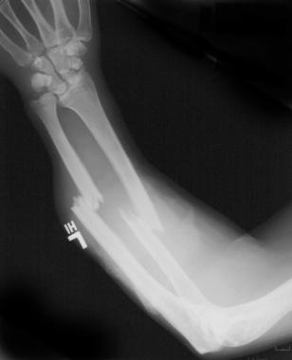The X-ray photo shows an injured arm. Which of the following statements is correct. The diagram shows:
2. Bones of a person suffering from osteoarthritis
3. A badly sprained wrist with several of the bones being displaced due to trauma
4. Damage to the radius and ulna bones of the forearm
5. The effect of an over-extension of muscles in the forearm causing ultra-rotation of the radius resulting in significant dislocation of the bones
6. 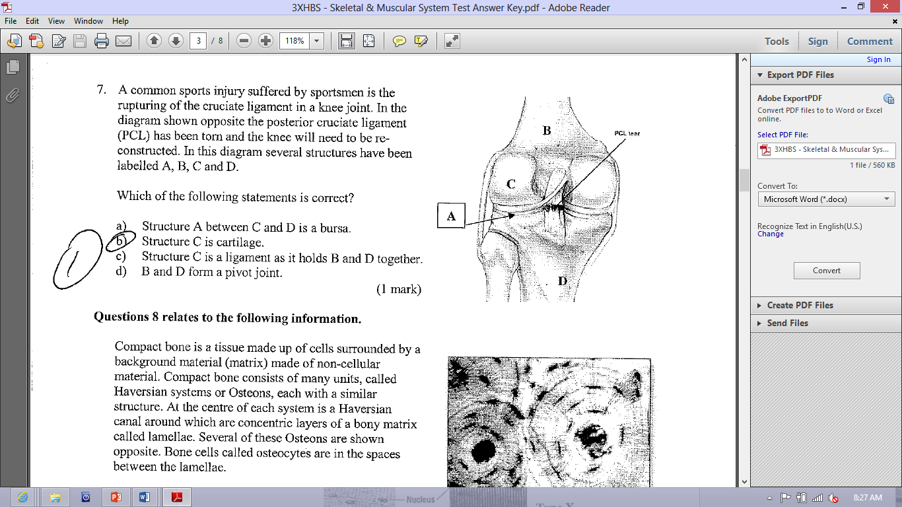A common sports injury suffered by sportsmen is the rupturing of the cruciate ligament in a knee joint. In the diagram, the posterior cruciate ligament (PCL) has been torn and the knee will need to be reconstructed.   
     
   In this diagram, several structures have been labelled A, B, C and D. Which of the following statements is correct ?
7. Structure A between C and D is a bursa
8. Structure C is cartilage
9. Structure C is a ligament as it holds B and D together
10. B and D from a pivot joint
11. How many bones are there in an adult human skeleton?
    1. 26
    2. 62
    3. 206
    4. 602
12. There are two types of bone marrow in long bones: red bone marrow and yellow bone marrow. Identify which statement is correct.
    1. Red bone marrow is found in the epiphyses whilst yellow bone marrow is found in the diaphysis of a long bone.
    2. Red bone marrow is where osteoclasts are stored and yellow bone marrow is where osteoblasts are stored.
    3. Red bone marrow is found in the epiphyses of the bone where blood cells are created. The cavity in the Diaphysis is used as fat storage as bone marrow.
    4. Red bone marrow allows nutrients to pass into cartilage as it hasn’t got its own blood supply and yellow bone marrow is where the nervous system enters bones.
13. In all mammals, the role of the skeletal system is to:
    1. Provide protection for internal organs
    2. Be an aspect of the endocrine system
    3. Stop dysfunctions to occur
    4. Maintain homeostasis

***SHORT ANSWER SECTION [32 MARKS]***

1. Look at the human skeleton, identify the following bones: [3 marks]
2. The ends of bones in a joint never touch. If they did, moving would be very painful. What fluid in the joint helps keep the bones from touching? [1 mark]
3. 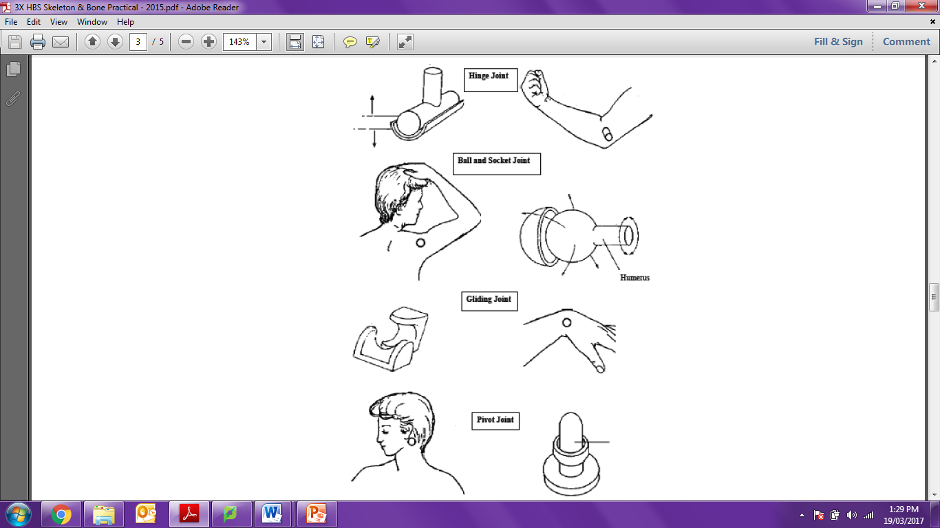The body has several different types of joints, each with specific features and functions:

Complete the following table as a summary of comparison of the joint types shown above:

[10 marks]

|  |  |  |  |
| --- | --- | --- | --- |
| **LOCATION** | **JOINT TYPE** | **BONES IN JOINT** | **ONE MOVEMENT PRODUCED** |
| Elbow |  |  |  |
| Shoulder |  |  |  |
| Wrist |  |  |  |
| Base of thumb |  |  |  |
| Neck |  |  |  |

1. The diagram below shows a joint in the human body. Name the structure and state the function of the structures indicated. [6 marks]

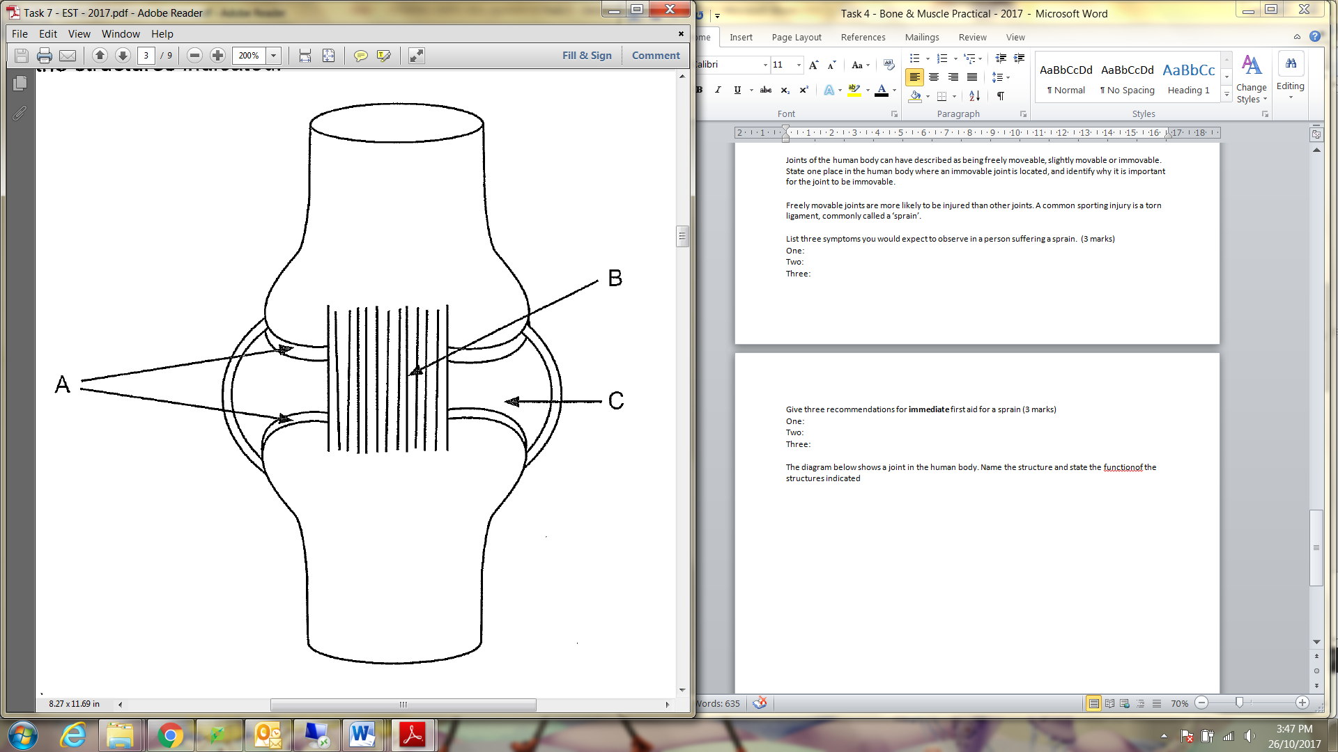

|  |  |
| --- | --- |
| **Name of Structure** | **Function** |
| A: |  |
| B: |  |
| C: |  |

1. Cartilage is a type of connective tissue found in the human body, usually between or at the end of long bones.
   1. Damage at a joint can result in injury to muscle, bone and cartilage. Explain why the cartilage at a damaged joint would take longer to heal than the muscle or bone. [2 marks]

____________________________________________________________________________

____________________________________________________________________________

____________________________________________________________________________

____________________________________________________________________________

* 1. If a bone is broken, osteoclasts and osteoblasts play an important role in its repair. Identify the role of each of these cells in bone repair [2 marks]

____________________________________________________________________________

____________________________________________________________________________

____________________________________________________________________________

____________________________________________________________________________

1. Joints of the human body can be described as being freely moveable, slightly movable or immovable.
   1. State one place in the human body where an immovable joint is located, and identify why it is important for the joint to be immovable. (2 marks)  
        
      ________________________________________________________________________________
   2. Freely movable joints are more likely to be injured than other joints. A common sporting injury is a torn ligament, commonly called a ‘sprain’. List three symptoms you would expect to observe in a person suffering a sprain. (3 marks)

|  |  |
| --- | --- |
| One: |  |
| Two: |  |
| Three: |  |

* 1. Give three recommendations for immediatefirst aid for a sprain (3 marks)

|  |  |
| --- | --- |
| One: |  |
| Two: |  |
| Three: |  |

***EXTENDED RESPONSE SECTION [10 MARKS]***

1. Children have layers of special cell in their bones called ‘growth plates’ or ‘epiphyseal plates’. Describe how a child’s long bone develop to form a mature bone [6 marks]

|  |
| --- |
|  |
|  |
|  |
|  |
|  |
|  |
|  |
|  |
|  |
|  |
|  |
|  |
|  |
|  |
|  |
|  |

1. A healthy lifestyle is essential during childhood and adolescence to build and maintain healthy bones. Explain why a diet with milk or dairy products and sensible sun exposure are important for improving bone health in children [4 marks]

|  |
| --- |
|  |
|  |
|  |
|  |
|  |
|  |
|  |
|  |
|  |
|  |

***END OF TEST***